Development

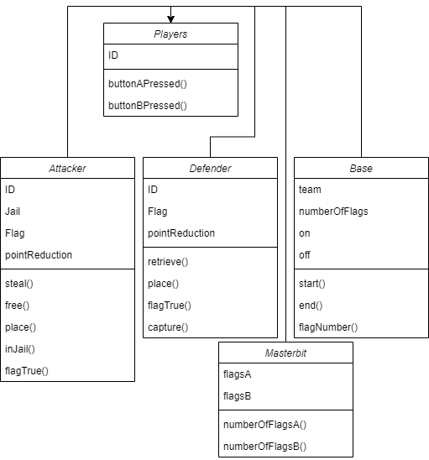
This is a current representation of the classes needed for my project. However, it is not in its final level as there are other classes required to initialise the game for instance, and use radio functions to establish communications between two microbits.

Game Basics/ Setup
Declaring global variables, classes and methods for my radio function.
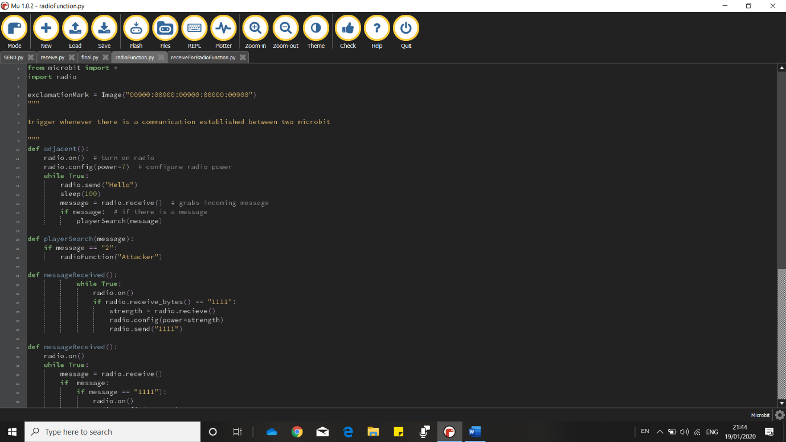
The numbers correspond to the line number
1 – This allows me to import all the functions available on the microbit library so that my code is compatible on a microbit computer
2 – This code allows me to run all functions in the radio library that isn’t in the microbit library to allow my microbits to communicate with each other
4 – When called, this line of code will display an exclamation mark on the microbit that called it to signal that there is a “complement” microbit near them
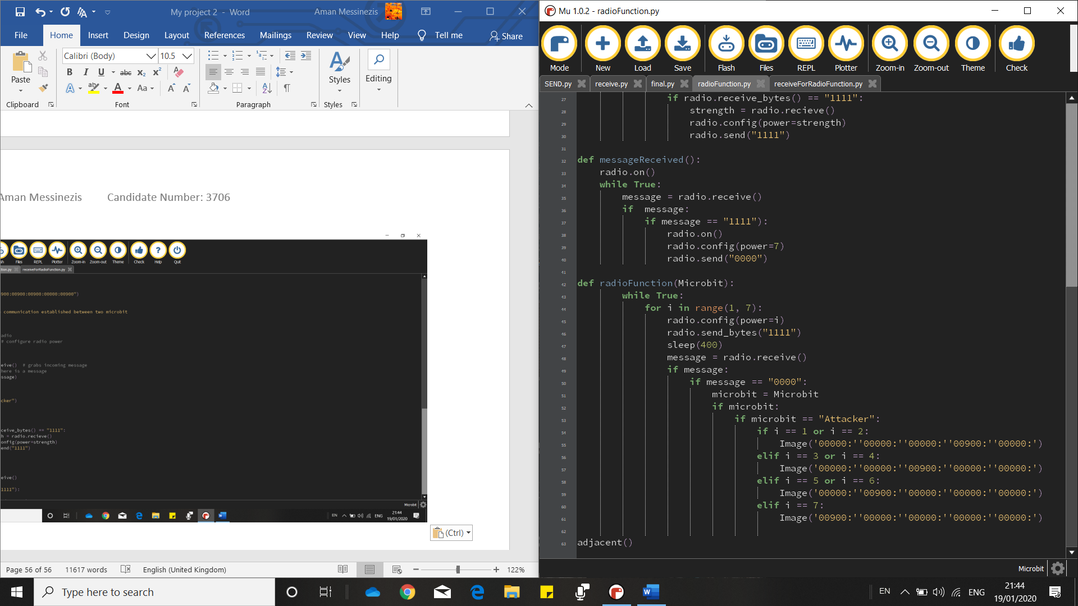
10 – This function is one of many functions that make up communication between two microbits. What this one does however is check whether there are any microbits nearby. If there is, the function will move on the next method, playerSearch(). The reason why these cannot be held within a class is because methods cannot call other methods within the same class. So instead, I have kept these functions within the same file, to give the idea that it is a class
In order for any of my radio functions to work, they must be turned on. They are default is off so that the microbit can conserve battery life.
My while loop is set to loop forever which checks if the following conditions are met which in turn, actions are applied. The sent message “Hello” is arbitrary and is a way for microbits that have a receive function to look out for any other microbits that are saying hello. If there is a message back, it Is then passed to the playerSearch function.
16 – This line of code grabs the next message in the queue held in the microbit.
20 – This function compares whether the message that was grabbed in the adjacent function was called “message”. It was sent using a function on a different file for a different microbit.
The if statement used compares the message passed form the adjacent function to a set of conditions that if true, will be sent to the radioFunction function. However, my playerSearch function only has one condition, being if the message is 2, then this maps to “Attacker”. There will have to be future conditions such as if the microbit is a defender, or a base, or the jailhouse.
42 – This function takes Microbit as the parameter. It’s supposed to display a pixel on the microbit to show how near “complement” microbits are to them.
What is being tested? | Input | Justification | Outcome | How to solve issues if there are any
My radio function. If there is an exclamation mark on the screen when the send to receive microbit shows an exclamation mark when close to the receive to send microbit. | Microbit at variable distances | To see if there’s an exclamation mark when the microbits are close enough | See video 15 | Syntax error line 37 radioFunction.py() file  Resolved  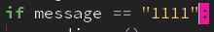
“ | “ | “ | See video 13 | Value error line 12 receiveForRadioFunction.py() file  Resolved  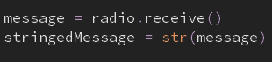
“ | “ | “ | Nothing displayed
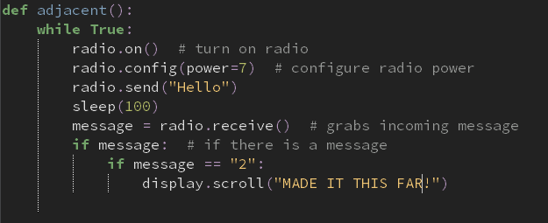
I adjusted my adjacent function in the worries of thinking that it wasn’t working. To make sure everything was going accordingly, I ended my radio functions at the end of my adjacent function where it will scroll “MADE IT THIS FAR” so that I knew that it was working accordingly. If not, I’ll know that there must be an issue with my adjacent function.
What is being tested? | Input | Justification | Outcome | How to solve issues if there are any
My radio function. If there is an exclamation mark on the screen when the send to receive microbit shows an exclamation mark when close to the receive to send microbit. | Microbit at variable distances | To see if there’s an exclamation mark when the microbits are close enough | See video 12

I figured that there was no point in having my playerSearch function as it could just be merged with my adjacent function, plus it only has very few lines of code.
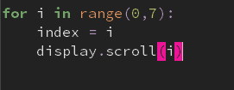
I did some code analysis for a for loop to see if that was the issue in the radioFunction function for my set of radio functions to withstand a communication as well as an exclamation mark to signal nearby complement microbits. I did this by creating a basic for loop which will display 0 to 6 on the microbit. By using an index, initially i which goes from 0 to 6, and gets displayed across the screen, then i is incremented by one. If you see video 12, you can see that it does work.
However, I wanted to adjust my for loop to see if it would work once a condition is met. This is via a while True loop which should wait until button a is pressed for my index to be scrolled across the microbit.
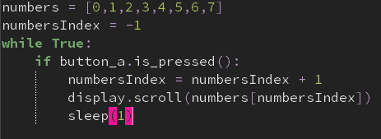
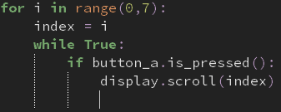
However, video 10 shows that only zero is displayed, which could imply that that’s what’s happening in my main code, and therefore, won’t properly work.

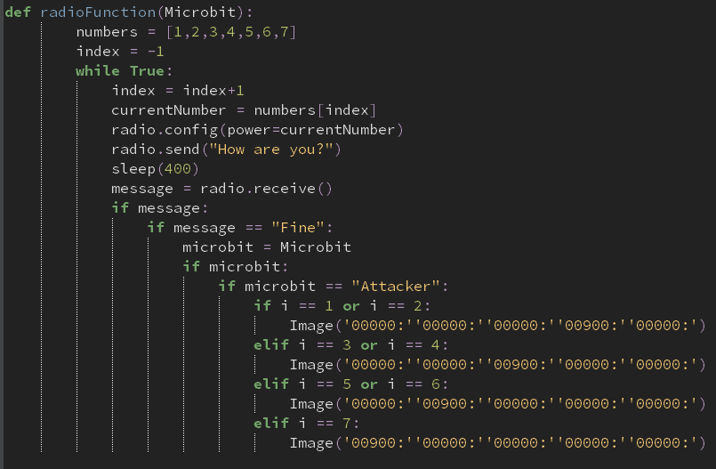
A way that I got around this is by making a queue which would be checked through a pointer. Video 9 shows that this works even with a condition applied. The queue called numbers goes from 0 to 7, and also comes with a pointer called numbersIndex that points to -1 first. My while True loop checks for a condition to be met, being if button a is pressed. If it is, my numbersIndex variable gets incremented by one.

I changed my for loop into the format that involves using a queue and a pointer

What is being tested? | Input | Justification | Outcome | How to solve issues if there are any
My radio function. If there is an exclamation mark on the screen when the send to receive microbit shows an exclamation mark when close to the receive to send microbit. | Microbit at variable distances | To see if there’s an exclamation mark when the microbits are close enough | Value error at line 11 | I haven’t turned on my radio.  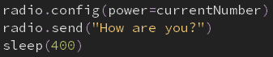  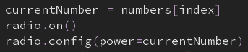
“” | “” | “” | Index error line 9 | I did not have an end to my implicit for loop. So, when index is greater than 6, I should end my function  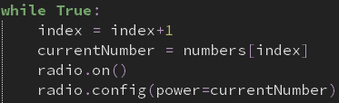  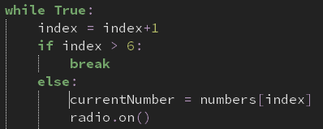
 |  |  | Blank display
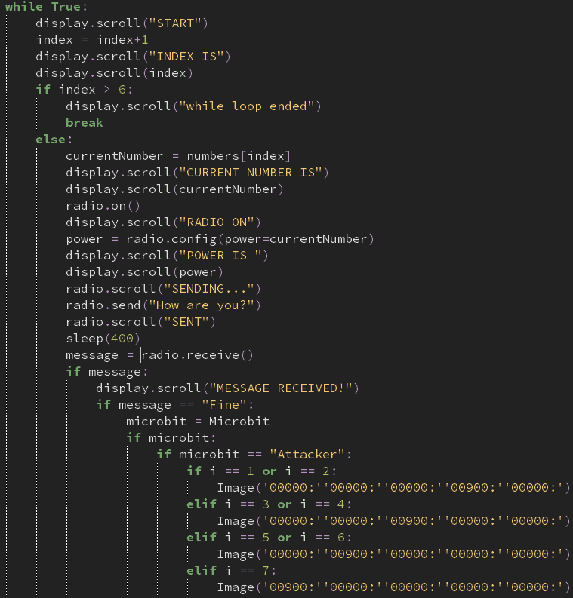
I decided to break my radioFunction down even further and see if certain lines were going accordingly. I did this by scrolling text across my screen at different sections of my function so I can pinpoint where I went wrong.

What is being tested? | Input | Justification | Outcome | How to solve issues if there are any
The radioFunction() | Receive to send microbit | Sends a message to the send to receive microbit which has the radioFunction | Attribute error at line 23 | Change radio.scroll to display.scroll  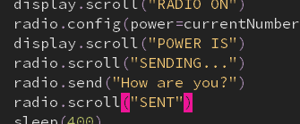  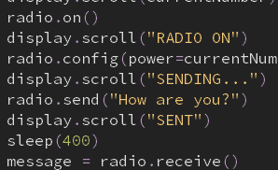
 |  |  | Name error at line 33 | Change i to index  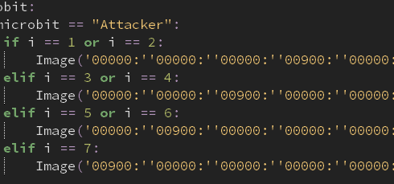
 |  |  | It doesn’t display a point on the microbit | Make a different function that displays the point on the map  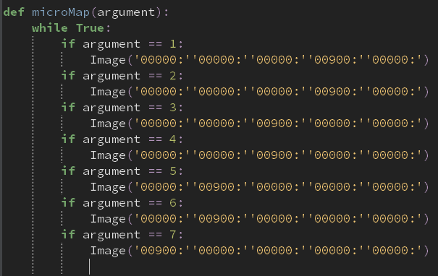
 |  |  | The micromap function isn’t defined | Work on the micromap function in isolation from the rest of the program
Micromap() to see if an coordinate is displayed on the microbit | Receive to send microbit | Send a message to the send to receive microbit | No image | Use the display.show() function  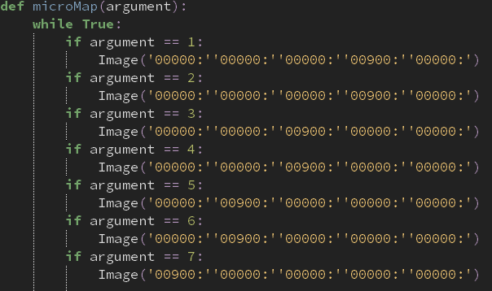  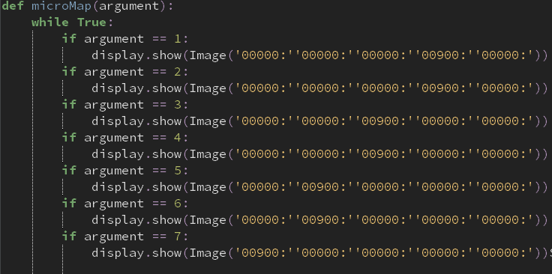
 |  |  | Works! A pixel is displayed at the second row of the microbit when 2 is the argument used. See video | Merge both functions together

It was working, as shown in the video, yet for it to be a loop that is checked forever, I wanted to edit my code in such a way for this to happen.
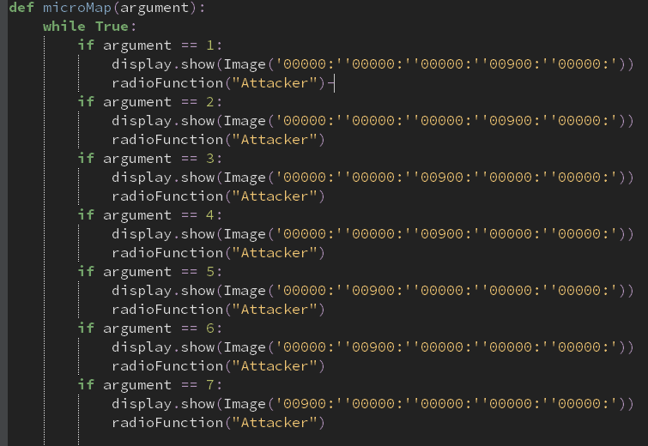
radioFunction(“Attacker”) was put under all my if conditions so that when any of them are me, the radioFunction gets called again. This would be a recursive method, which may lead to a stack overflow error. In addition, I couldn’t simply let the while loop in my radioFunction loop to be used as it and the microMap function are two separate functions.

What is being tested? | Input | Justification | Outcome | How to solve issues if there are any
The robustness of my function | Receive to send microbit | So it can send off a signal to me send receive microbit which is then delegated to the radioFunction | See video… I got a runtime error in line 30. | Perhaps merge my two functions in a way that it would only require one function so a while loop can still work out.
 |  |  | See video… the pixel moved to the top of the microbit display even without having a change in radio strength | Assign index to -1 once an image has been displayed  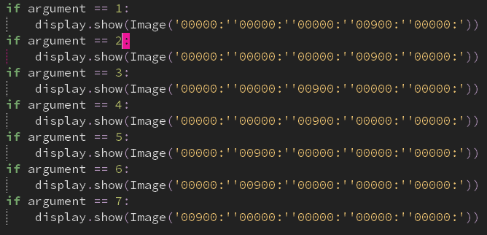
 |  |  | See video! Working
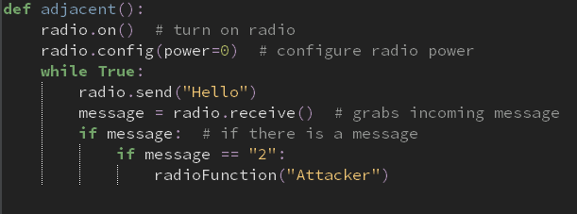
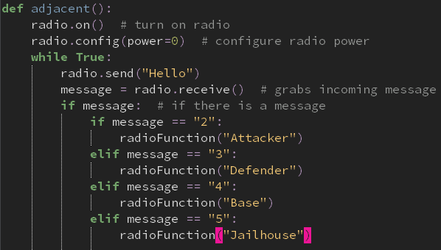
My adjacent function establishes a connection between two microbits and passes a value to the radioFunction() function, depending on what message is sent back. However, it hasn’t been fully validated as it hasn’t taken conditions from all types of microbits
The updated code, from line 10 onwards, allows validation from different types of messages that are sent back to the send-received microbit.

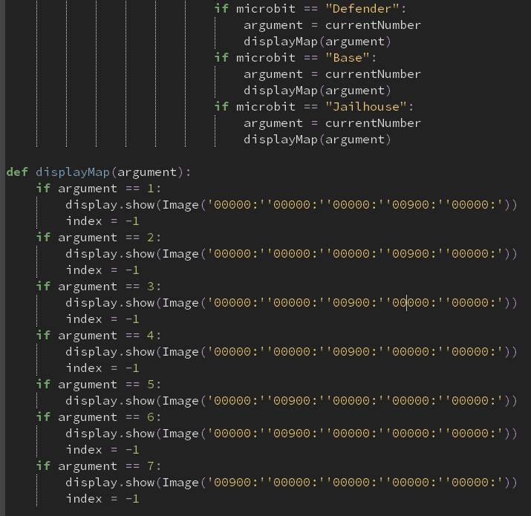
I wanted to further develop my code by creating a function that would essentially be its own subroutine to display an image on the microbit screen, depending on whatever argument is passed to the function. However, I noticed that it wouldn’t work because the index variable wouldn’t be understood by the function. The purpose of that variable is to change the pointer in the list in the radioFunction() subroutine is to -1, so that it can loop through the list again.

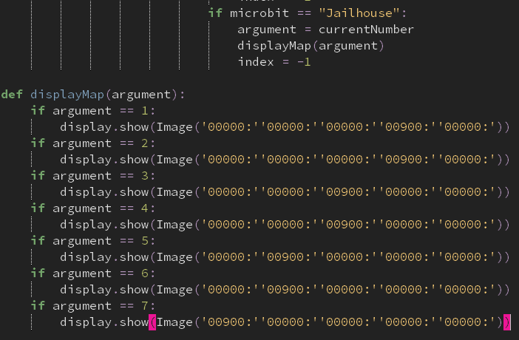
The following is a revised version of the code above. I have improved it by removing the index variable and moved it so that it is within my radioFunction subroutine, and also keeping my displayMap function so that it can be called from anywhere in the program without the need of “messy” code.

What is being tested? | Input | Justification | Outcome | How to solve issues if there are any
radioFunction with the addition of the displayMap subroutine | Receive send microbit | To send a message to the send receive microbit which has the radioFunction and the displayMap function | Empty screen | Remove the displayMap function and insert the code within that subroutine in the radioFunction subroutine. This is so I can have a good understanding with which function is not working.  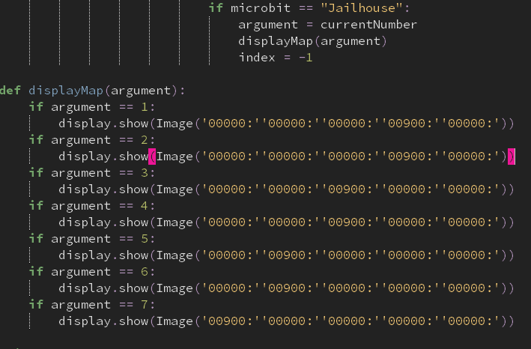
 |  |  | Empty screen | Perhaps by backtracking and comparing both functions before adding other microbit conditions in the adjacent and radioFunction subroutines
 |  |  | Working solution again | 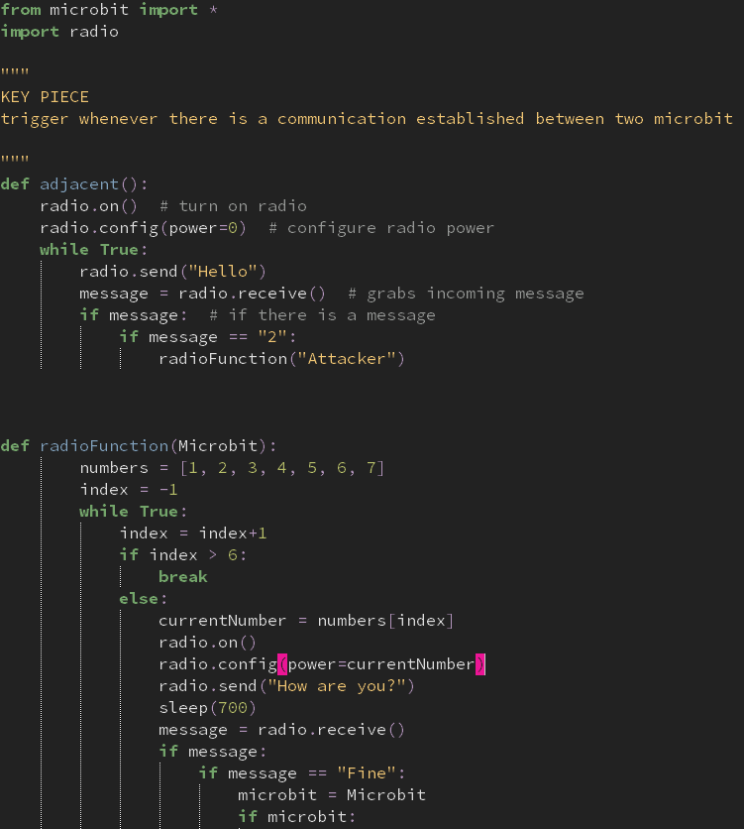  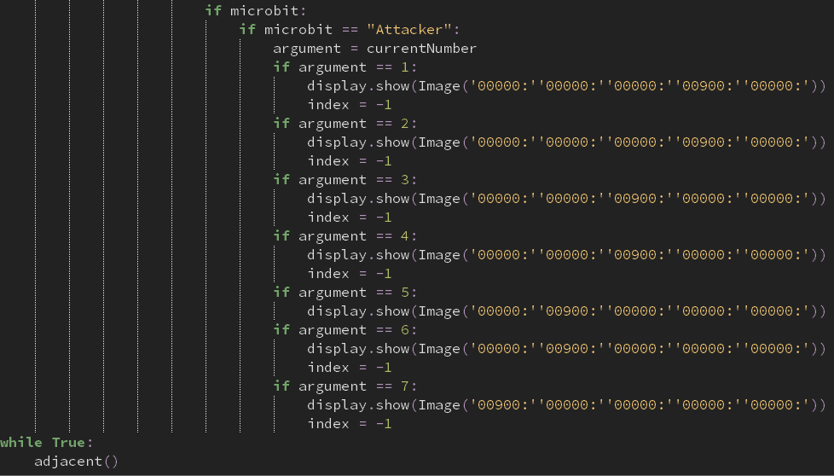  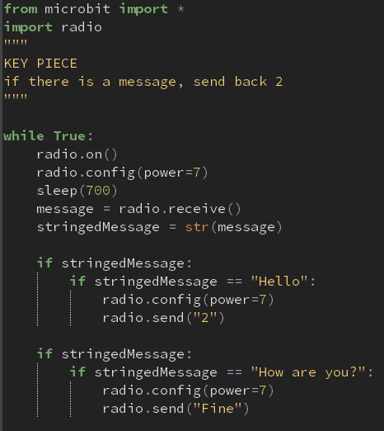  The following coded solutions show my radioFunction, adjacent, and the functions used in my receiveforRadioFunction are all working accordingly.  My next steps are to implement more conditions to the rest of my program wherever needed to make it flexible for all types of microbits.

There were slight errors to my display when compiled. I created trace lines of code so I could see what values were being passed through my microMap function. The video footage had shown that there were numbers being passed that shouldn’t have been. I decided to go back to my radioFunction and debug the issue as I knew that that was what was going on. I was going to trace through my code so that I could hopefully pinpoint where I went wrong.
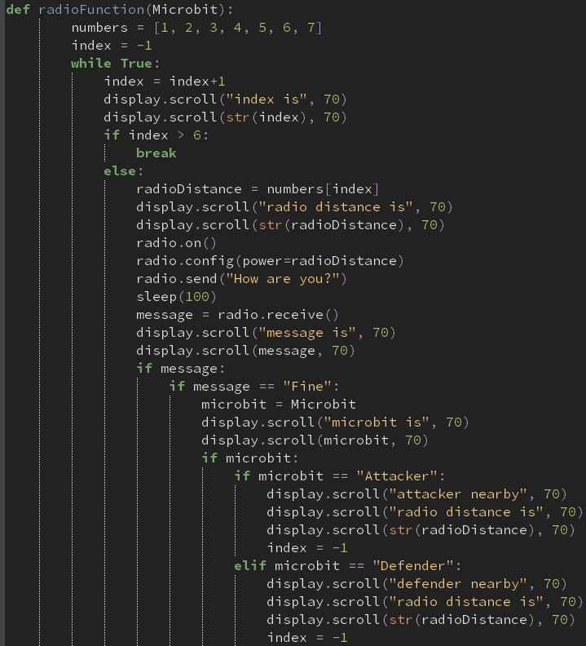
This screenshot is my radioFunction, still with the same code. The only difference is that I’ve inserted more lines of code so that I get a good understand of what all my variables are assigned to, especially how they change during the while loop

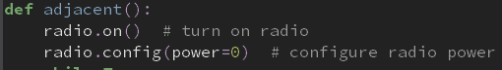
I realised that I had configured my radio to 0, so no message was sent at all!
Furthermore, I got a memory error when converting my python code into readable bytecode for my microbit to understand, due to the RAM running out of space. For this reason, I’ve currently removed all comments and deleted sections of my code to free space.
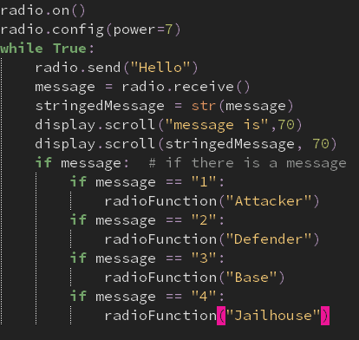
My send to receive microbit was also not receiving messages. I spotted the error that I hadn’t put the microbit to sleep, as it does have to wait for a message to get sent to its queue. The screenshot below is a developed version of the code to the left.
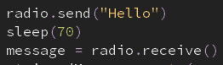

I successfully resolved the error of having different indexes. The main reason was due to the fact that there had to be a button that was pressed for the send receive microbit to be activated. Or else, the receive send microbit wouldn’t be receiving anything and would return None to the send receive microbit.
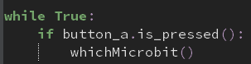

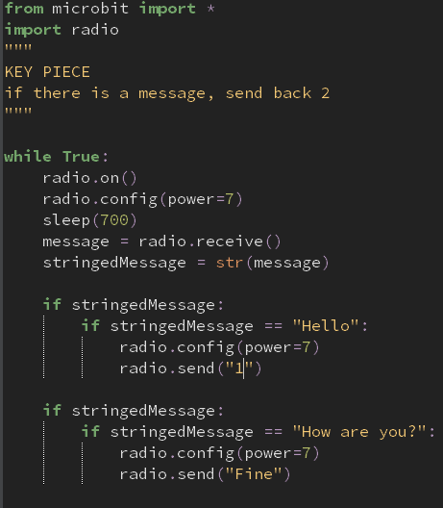
The following code screenshots show different receiving functions from different microbits. The reason why I made this is so that my microbits could receive radio communications not just from one microbit, but several. Right now, the main problem I’m facing is threading several files so that it can work seamlessly within my microbit display screen. Currently, there is only a pixel that is displayed on the middle x axis and moves in the y direction depending on the distance between the microbits; it’ll be difficult to include different microbits on the screen without the game being too confusing. Worst case scenario would be having only one pixel, but detects the closest microbit to them, and that’s what’s focussed on. I also need to be aware of the “complement” microbits (i.e. attackers will complement the opposition base and defence microbits, and the defence microbits will complement the attacking microbits from the other team.
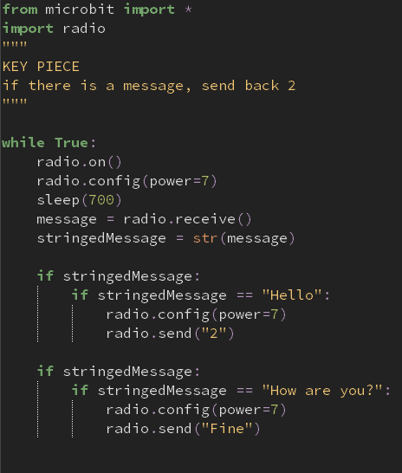
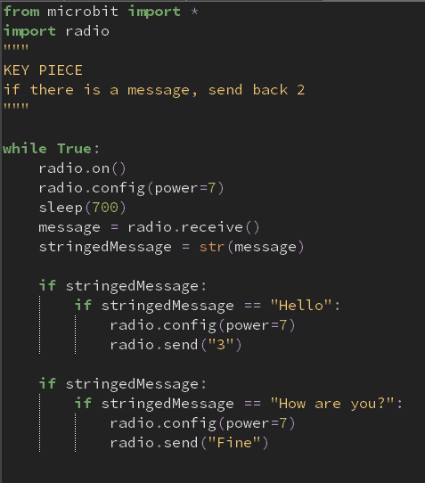
What I have done to test these files to see I know that the correct one is being run once compiled is to adjust the brightness of the pixel on the screen, depending on which microbit receive file is being used.

What are you testing | Input | Justify | Outcome | How to improve
microMap function | 3, Attacker | To see if the correct brightness as well as the location of the pixel is displayed | See video  The brightest pixel intensity in the correct location | NA
 | 1, Jailhouse |  | See video  The weakest pixel intensity in the correct location | NA

Now that I have a clear understanding that my subroutine is working accordingly, I can minimise the size of it as intensity was just a way for me to know that the code points to the right location, and it is working accordingly.
See video for a full working version of the radioFunction
The radioFunction is officially working.

The following program will consist of an object-oriented based strategy of creating my players. The reason why I’m using object-oriented programming to do this is because it can bind together the data and the functions that operate on them so that no other part of the code can access this data except that function. Attackers, defenders, bases, jailhouses and the masterbit all funnel through to be the “characters” of the CTF game. I would need to create characters that require slight altercations. For example, the only difference between the attacking microbits is the unique ID given to them; everything else is the same: methods and data they hold. To reduce the number of code needed to be written, object-oriented code keeps my project easy to work with. And if I need to alter a character in my game, rather than having to go through all 8 attacking programs, as there will be 8 attackers shared between teams A and B, using object-oriented programming allows me to work with it on one file.
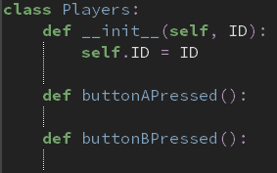
My parent class called Players will hold the ID of any instance that uses the Players class, and will be used across the rest of the classes within my parent class, Players, called sub-classes. My sub-classes will consist of the characters within the CTF game, acting as a blueprint to create the actual object code.
The self.ID line will allow me to refer to the current instance of the class, and is used to access variables that belong to the class. So therefore, I will be assigning whatever ID is passed in my Players class, directly or indirectly, as the instance of the class’ ID.
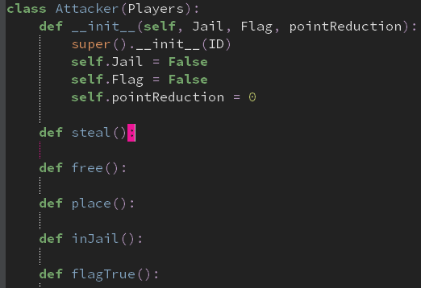
The child class Attacker is a sub-class of the ancestor Players, as displayed in brackets in the first line, as well as in the third line. The reason why I had to state this twice is because python syntax makes it no longer possible for Attacker to inherit the Players __init__ function, as another __init__ function is used in the Attacker class, overriding whatever is in Attacker’s parent class. The only way to inherit the parent’s __init__ function is to add a call to the parent’s __init__ function within the child __init__ function. This allows it to inherit data within the Players class, which is ID.
Attacker further comes with Jail, Flag and pointReduction given as the data within that class. These parameters are used to access functionalities within the Attacker class, i.e. steal, free, place, inJail, and flagTrue.
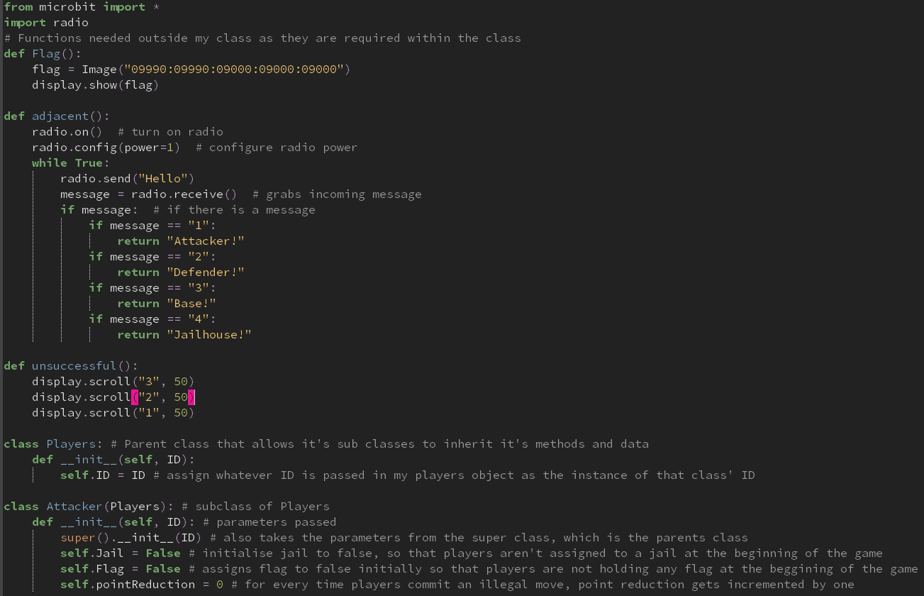
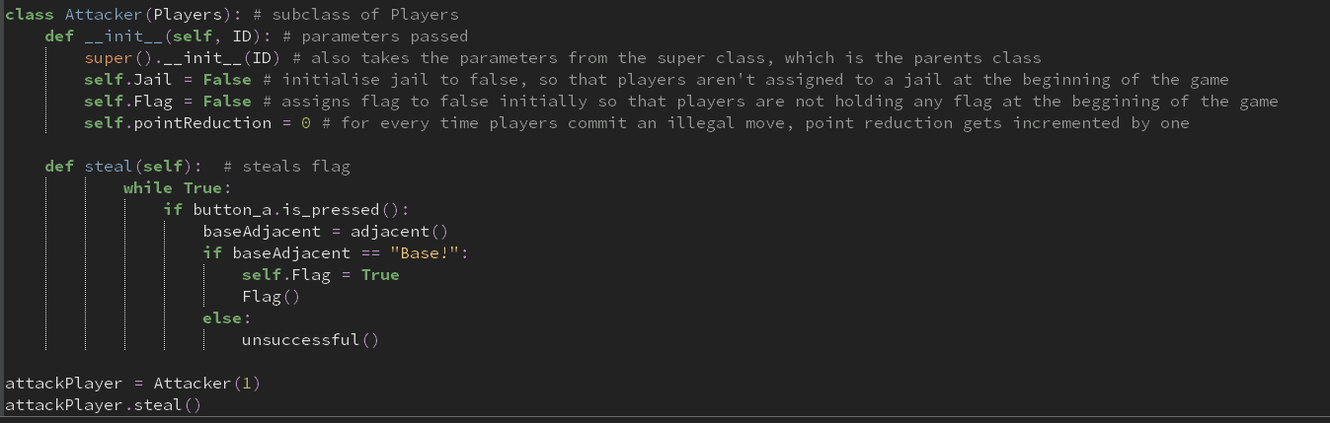
The screenshots above show a developed version to my Players class. It only consists of the parent class, Players, as well as an Attacker sub-class. It also has two new functions called adjacent and unsuccessful. Adjacent is a polymorphed version of my whichMicrobit function used in my radioFunction, only that the power is assigned to one. I did this because the only way that a flag can be stolen is if both players are at a very close distance. Power=1 achieves this criterion for my steal method in my Attackers class as it requires a close distance for the method to be true. The unsuccessful function simply displays 3, 2, 1. The reason why I defined this function is because it acts like a cooldown timer, only when certain conditions are met. For example. If players aren’t close enough, which they will know as it’s displayed on their screen, the cooldown timer will be initiated. This is a great way to eliminate any cheating, by repeatedly pressing A, in hope that they will steal a flag. Olivia, one of my stakeholders tested this function out and she believed that the cooldown way too quick, and in order to keep the game’s tense vibes, it should slightly be altered. Therefore, we both agreed on a duration of 150milliseconds from 250 milliseconds.
What am I testing | Input | Justification | Outcome | Improvements needed?
Steal function | Button_a and defender | To see if the desired outcome is displayed on the microbit screen that presses A | “Unsuccessful” function displayed, see video | NA
Steal function | Button_a and base |  | Flag displayed, video | NA

The only problem I’m facing right now is making sure that even with no microbits nearby, there should still be an unsuccessful function triggered. But I will focus on that later on as it isn’t a major issue.

Defender is a subclass of Players, by inheriting the ID attribute. It takes two parameters, flag and the ID, which is retreived via Players superclass. The initialised variables it holds are Flag and Pointreduction. The reason why flag is assigned as false is because at the beginning of the game, the flag is held in the base, and will be assigned to true later in the game when they steal the flag from attackers from the other team. Point reduction will increase if defenders commit an illegal move such as stepping inside the radius of the base or the jailhouse, to prevent cheating.

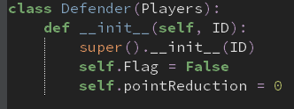

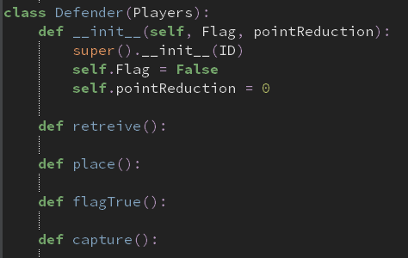

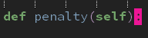

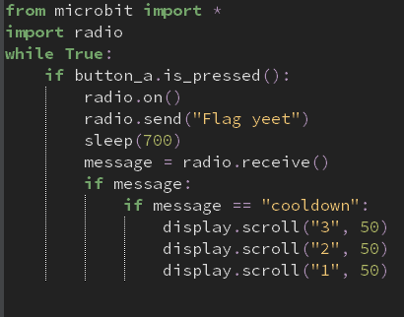
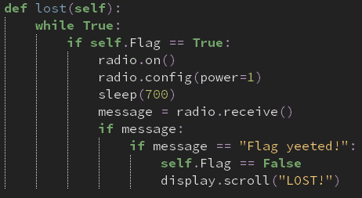
As my analysis explains how the defender’s objective is to protect their base from enemy attackers stealing flags from them, stealing flags is a way for these defenders to redeem themselves for having the attacker stealing the flag in the first place. This lost method is called when a radio signal is sent to the attacker with the flag from the defender who has successfully retrieved the flag back from the enemy team. I used a while loop so that the block within my method is checked an infinite amount of times whenever it’s called during my program. It checks whether the current attack object has the flag. If this is the case, it then checks whether there’s been there’s a message sent to them. If “Flag yeeted” is what’s received, then the program gives up the flag and sends it back to the opposing team’s defender
What I’ve done to test this is by creating a few lines of code that, when a is pressed, attempts to steal the flag from the person holding the flag and sends a message which is altered for the sake of development purposes. A cooldown is initiated if the attacker doesn’t have the flag.

What’s been tested | Input | Justification | Output | How to solve problems if there are any
Lost method | Attack set to flag is true  Defence pressing button a at a close distance | To see if the attack object has flag set to false when retrieved from opposing defence | See video | NA
 | Attack set to flag is false  Defence pressing button a at a close distance | See that my first if statement works | See video | NA
 | Attack set to flag is true  Base pressing button a at a close distance | To see if the message received is what triggers “LOST!” to be displayed | See video | I forgot to assign flag to False after changing it to false in the previous testing
 |  |  | See video | NA

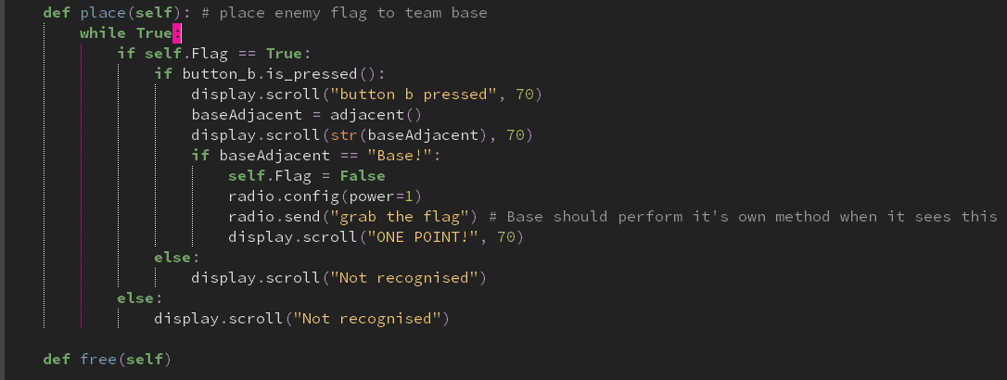
In the breakdown of my problem, I explain how attacking players, when the flag is assigned to the, have to place the flag in their base without getting caught by defenders. The place method within my Attack class within my Players class allows them to do so. When the b button is pressed, the adjacent function is called which is in the same file as the rest of my Players sub class. If the base function is returned, the flag that the attack initially holds and was set to true gets set to false. Radio communication allows my attack microbit to tell the base microbit to increment it’s number of flags variable by one. I have made my code robust by using validation techniques so that pretty much all input will return an appropriate output. If the attack doesn’t hold a flag initially, then the screen of the attacker’s microbit will display not recognised, as well as when button b is pressed. For the sake of testing, I have added trace statements throughout my method to see how variables are initialised to and also see where I have gone wrong in my program.
What am I testing | Input | Justification | Output | Improvements needed? If so, what are they
Place method | Base | It’s a condition needed to allow the attack microbit to tell the base microbit to grab the flag | “Not recognised” displayed on screen  See video | Remove the first else statement as button b would have to be pressed instantaneously for that statement to not be passed  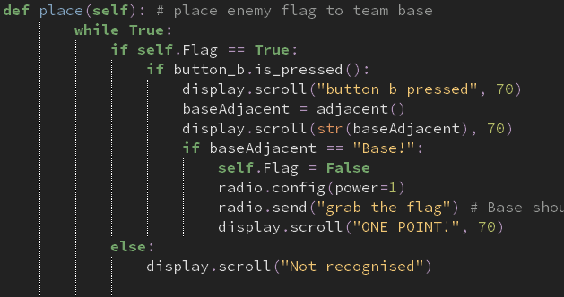
 |  |  | It goes all the way to “ONE POINT!” however also displays “Not recognised”  See video | The reason why it displays the else statement is because my place method is a while statement and will always check through. Therefore, when self.Flag is assigned to false, meaning that the attacker doesn’t have the flag, that’s the new assignment. This then would have to mean that when it’s looped the second time, it would have to pass “not recognised”. In conclusion, the only way for this to not happen is to remove my else statement  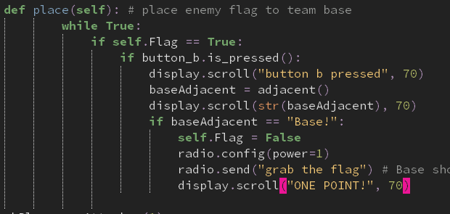
 |  |  | Goes all the way to “ONE POINT!” with no other statement s after  See video | As I know that it’s working accordingly, I now have to remove my tracing statements such as “ONE POINT!” and actually use another function to set the points within each Base class.
 |  |  | MemoryError on Base microbit.  See video | Try removing as many whitespace and comments when possible.
 |  |  | “Not recognised” displayed and when button b is pressed, no change in display | Perhaps changing the else statements so I can recognise where my error is  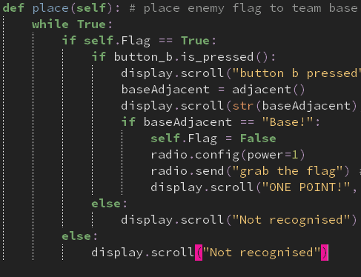
 |  |  | By deleting both else statements, my attackerBit was working. However, the message sent was “None”. | Noticed that the attackBit was sending “grab the flag” whilst the baseBit was looking for “FLAG!” to be received on their end.
 |  |  | “None” is the message returned and displayed on screen, using the tracing algorithm | There isn’t a number assigned to the baseBit which corresponds to a microbit for the adjacent function  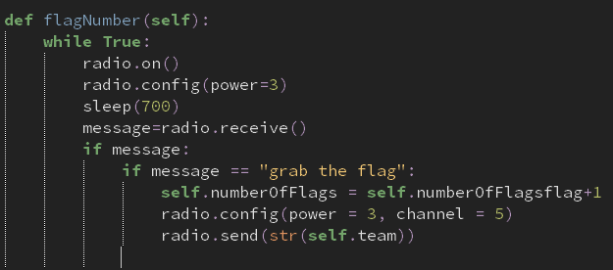  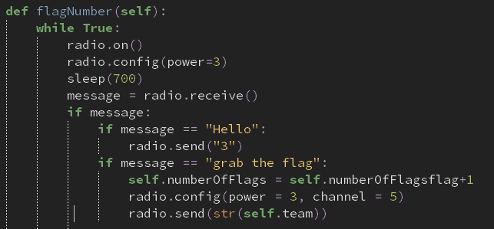
 |  |  | “ | No batteries
 |  |  | Attribute error at line | I forgot to assign an instance variable in my __init__ method called “numberOfFlags”
 |  |  | See video – Works | NA

The place method in the attack class and the flagNumber method in the Base class are working!

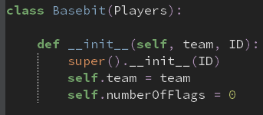
Base is a subclass of the Players class. The purpose of this class is to store the flags that are retrieved in game, as well as when flags are stolen. Initially, the number of flags would obviously be zero, until they have been stolen from the other team and successfully placed in the team base, which will then increment this by one every time. The reason why team is a parameter it so that the scores that are held in the base is fed to the masterbit class through radio communication that the microbit can do. Therefore, when button a or b is pressed on the masterbit, the scores are permanently stored on the masterbit and can display the number of points that both team a and b have overall, even from past games.
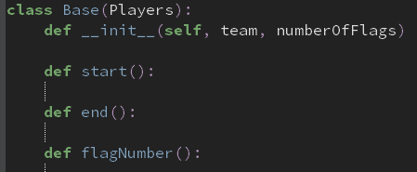

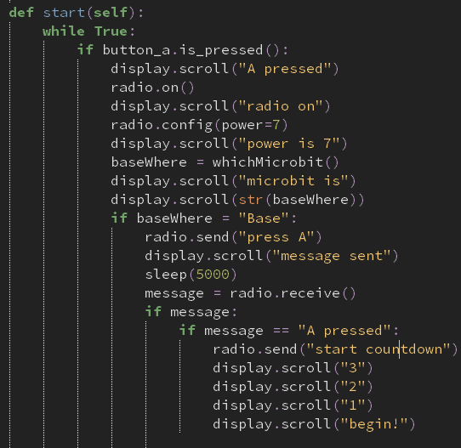
One altercation of the original CTF game is that base’s have to be on in order for the game to start. This is so all variables are initialised and flags can be stolen and placed to gain points. The start method in my Base class performs this action. When button a is pressed on the host basebit, the guest basebit receives a radio message that instructs the guest to press a in 5 seconds. If this is successfully performed, then a countdown will begin, and another function will be made in the future where all microbits have full functionality.

What am I testing | Input | Justification | Output | What to do
Start function | Radio messages from guest and host | For the countdown to begin | Syntax error at my second if statement | It must have a double equals sign as I am comparing two sets of data.    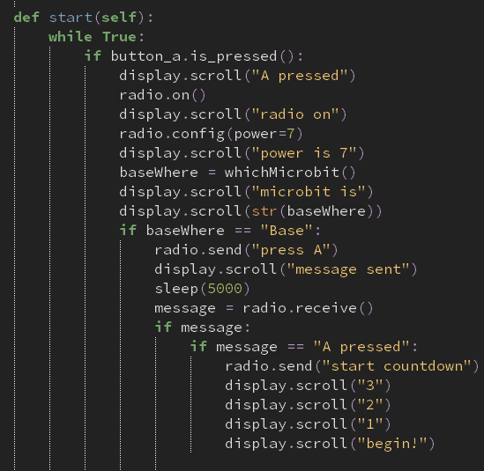
 |  |  | Name error at my whichMicrobit function | It uses a different function which I discarded for the sake of ease of testing. Instead, I will use return.
 |  |  | The happy face was displayed, but when I pressed button a, there was no countdown | Add a while loop inbetween the happy face line of code and the if statement in my guest bit.
 |  |  | When I press the A button when the happy face appears within the 5 second window, the countdown is initiated, however, the host waits for 5 seconds rather than doing the countdown simultaneously with the guest countdown. | Implement another while loop where it will check from 1 second to 5 seconds if a radio message is sent  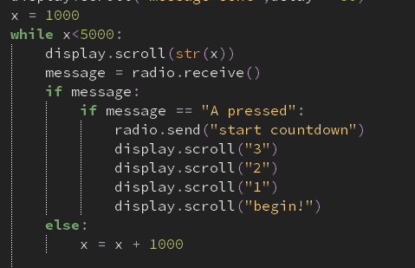
 |  |  | While loop is broken once a radio message is sent, however, it goes back to it when it shouldn’t | Set the while loop to True and when the message is sent to the host, the while loop should terminate.  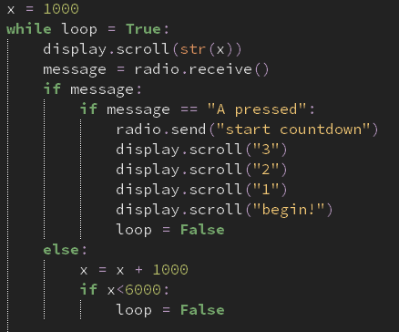
 |  |  | Syntax error at while loop = True | I recognised that because I’m using the comparative symbol equals, rather than the assigning symbol equals, I should use double equals, rather than a single one  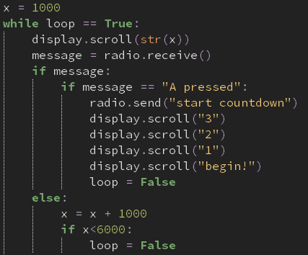
 |  |  | While loop ended too soon | Notice that my final comparative symbol should be > and not <  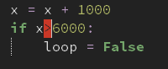
 |  |  | See video, it’s working. | Now, I have to remove the trace algorithm to hopefully make both microbits perform the countdown at the same time
 |  |  | No countdown. Empty screen. | I realised that I didn’t use the sleep function  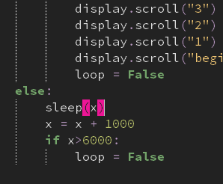
 |  |  | See video | NA

My start methods are working.

The end methods within my base class was pretty easy to program. This is because it followed the exact same formatting, only that a minor change had to be done for it to work. For example, the radio message that’s being sent, and the name of the method.
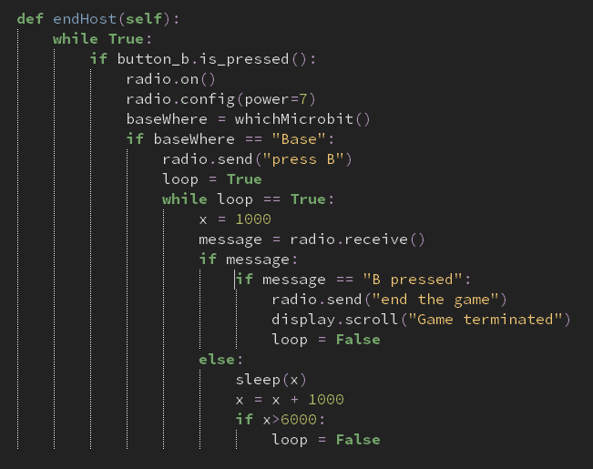
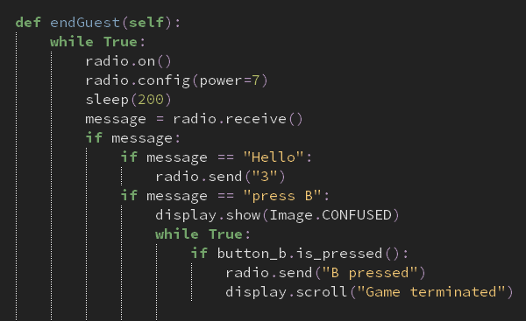
What am I testing | Input | Justification | Output | What has to be done?
End methods | Radio messages from guest and host | For the game to end | See video | NA

My end methods are both working.

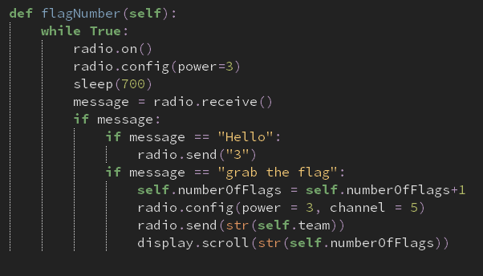
Flag number is a method also held in the base class. The purpose of this method is to increment the flags held within the base, essentially probably being the most important method within the base class. Simultaneously, for every flag that is collected, the flagNumber method allows the base to communicate to the masterbit and send the number of flags that it contains.
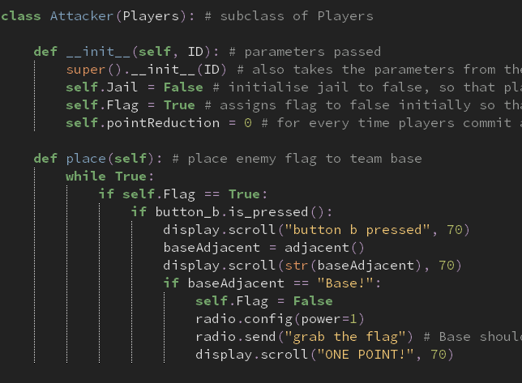
The reason why I am using this method from my Attack class is because in order for a flag to be placed in the base, it must be placed. The place method within my attack class is the way to perform this
What am I testing | Input | Just | Outcome | What’s needed to be done
FlagNumber method | Attacker | Places the flags in the base, which will then require the value of the number of flags to increment by one
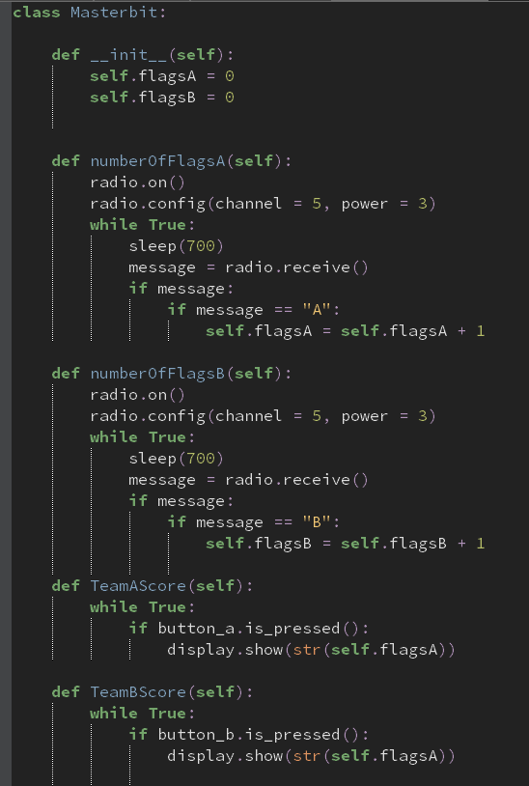
To keep track of scoring for both teams, the masterbit is kept well away from the in-game match, but not too far away so that radio signals aren’t reached to the microbit that behaves as the masterbit. A problem with the obsolete CTF game is that scoring may be difficult to keep note of because there could be players that may cheat and give more points to their team for example. A great way to come across this is to let a program handle the scoring to eliminate any kerfuffle between the two teams. It will infinitely loop through different methods within its own class, by having the bases feed through the number flags it currently holds to the masterbit, to act as storage to hold the number of flags for both teams. The way they can access this is by simply pressing button a or button b to display the score of either team a or team b respectively.

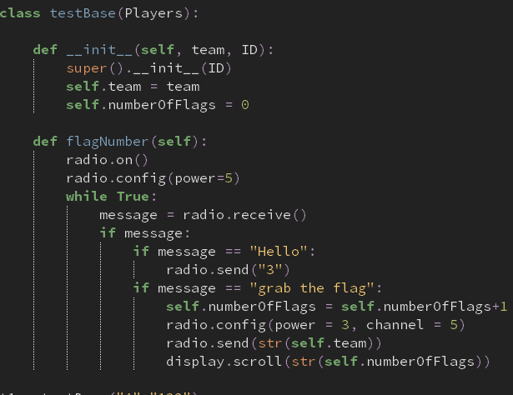

This is a test version of the base class which I have altered in such a way, for ease of testing, by allowing me to press a to increment the flags in the base by one, as well as feeding that value to the masterbit.
What I will be testing | Input | Justify | Output | What to do
NumberOfFlagsA | T1 = testbase(“A”,”123”) | Sends the current number of flags to the masterbit | See video, works! | NA
NumberOfFlagsB | T1 = testbase(“B”,”123”) | “ | “ | “
TeamBScore | Button b | When pressed, it displays the scores on team b that it has | Nothing on display | My display function I use is for team A, when it should really be for B.  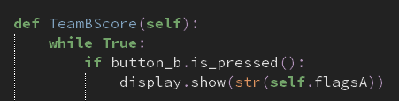  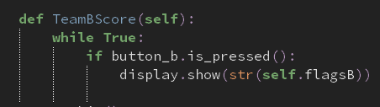
 |  |  | Nothing on screen | See if there’s something wrong with the display function by changing the argument given to an arbitrary word  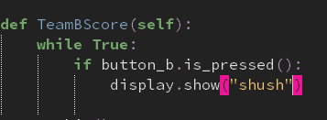
 |  |  | Nothing on screen | Recognise that it should be scrolling, rather than showing  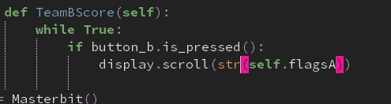
 |  |  | “ | Should be team b, NOT team A  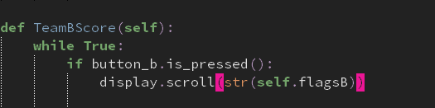
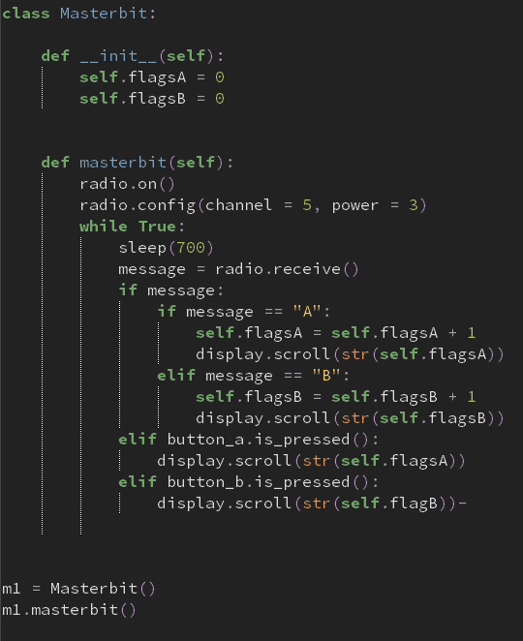
After several attempts, I noticed that this is actually the first time I’m using calling two separate methods within my testing, assuming it won’t mean no difference. However, when I create an instance of a class and then call two methods, which both contain infinite loops, it will stay in that block of code until it’s set to false, which it never does. Therefore, from hereon, essentially ALL of methods will have to be conjoined as one big method. The code below shows a developed solution of my masterbit class, which now works.

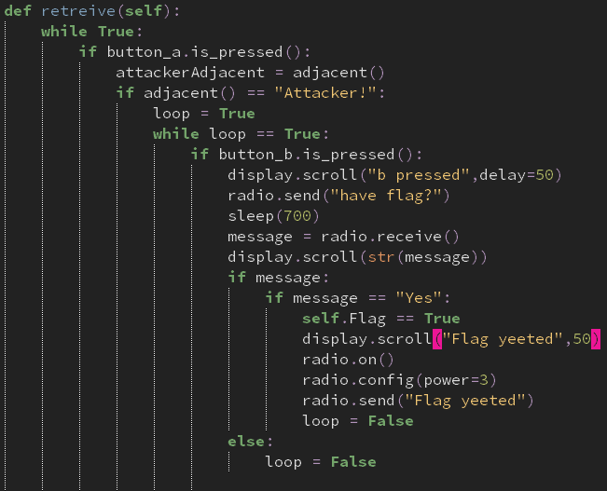
The purpose of the retrieve method is to take back team flags that are currently held by enemy attackers. This method belongs to the defender class, meaning that only defenders can commence this method when nearby to attackers and press B.

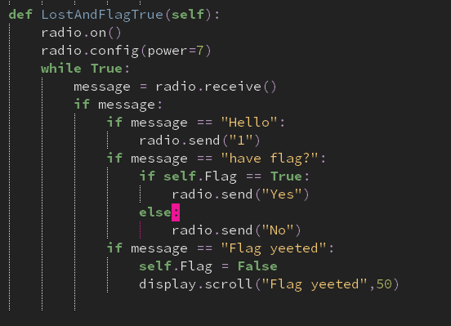
For testing purposes, I made a simplified version of the attack class, by using the methods required for the retrieve method to work. One being if there is an attacker adjacent to the defender, one if the attacker is holding a flag, and one to signify that the flag has been taken, or “yeeted”.

What’s being tested | Input | Just | Output | What has to be done?
Retrieve method | Attackbit | Radio signals allow the method know whether there’s an attacker holding a flag so it can be executed correctly | See video, works | NA

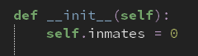In CTF, when a defending player catches an enemy attack that has no flag, they get sent to jail until their fellow attackers free them. The jailhouse class stores information of who’s in the jailhouse and who isn’t. The initialisation variable is inmates, set to zero. This is because at the beginning of the game, all players are on either side of the arena, and so no one would be in jail, until caught by the defenders, which will then increment the value of self.inmates by one. Jailhouse isn’t a subclass of Players because it doesn’t require the IDs of players as an initialisation variable.
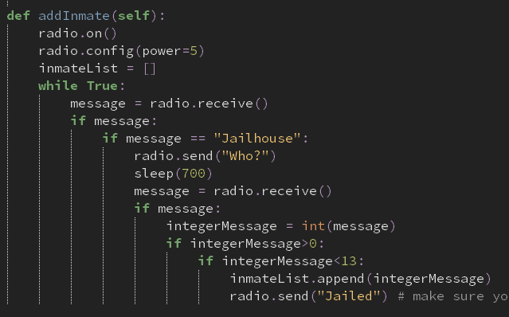
When a defender does successfully catch an attacker, it has to send that attacker to the jailhouse. The jailhouse receives radio signals to know that there’s a new inmate and what their ID is. This actually hasn’t been done in the defender class. However, majority of the capture method has been implemented and all that has to be done is to send a couple of messages to the jailhouse.
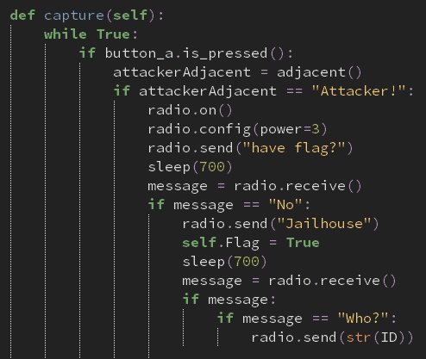
This is the developed version of my capture method within my defence class. What I have added is from radio.send(“Jailhouse”) onwards.
What am I testing | Input | Just | Outcome | What do you have to do
Capture | Attacker presence and no flag | So attacker can get sent to jail | Nothing on defender screen | Change the boolean value of self.Flag to False  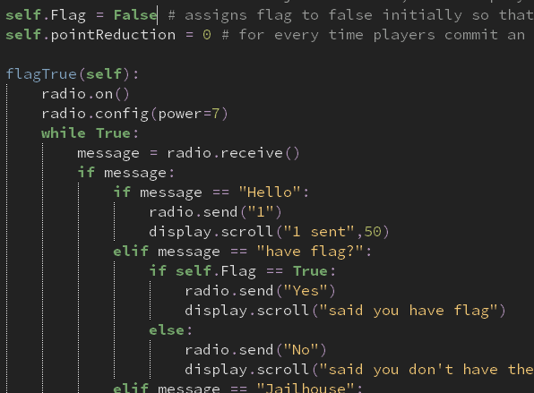
After plenty of attempts, I decided to rewrite my while loop and I ended up with the correct solution.
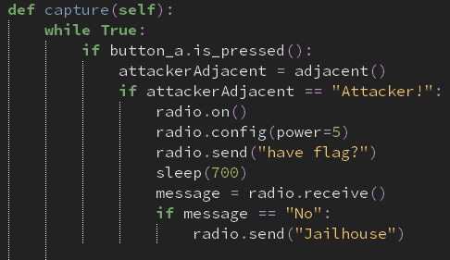
I now have to update it so that it can establish a connection with the jailhouse.
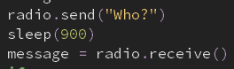
What this block of code does is ask for the ID of the attacker that has been caught. In a sense, indirect communication is made, as the defender then has to ask the attacker for their ID, which is then sent back to the defender, which is then sent back to the Jailhouse microbit. The defender has to switch channels for this to happen so that there aren’t any communication errors between two microbits. The two code screenshots below show the defender asking for the ID and the attacker giving it to the defender respectively.
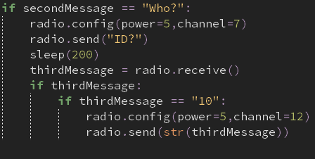
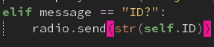
For testing, I have changed the final line of the addInmate method so that it displays “jail” when the message has been sent from the defender microbit
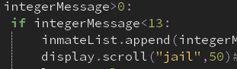
What’s being tested | Input | Just | Out | What next
Communication between jail and defender | Defender | Sends the ID | Line 58 Value Error | Turn on the radio  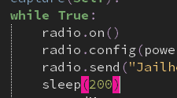  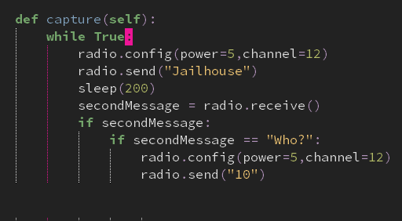
 |  |  | Line 50 value error after “jail displayed” | End the loop so that it doesn’t take “None” as a message. This is done by assigning the while loop to loop = True and until that’s false, it cycles through that loop.  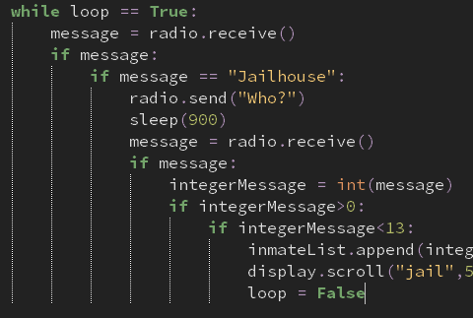
 |  |  | See video, working | NA
Defender and Attacker communication | Attacker | To see if ID is sent to defender | See video, works | NA
Defender and Jail communication | Defender | To see if the ID is sent from the defender to the jailhouse | See video; works | NA

As both sides of communication are working, there is no need to edit anything.
Therefore, my jailhouse addInmate method is working
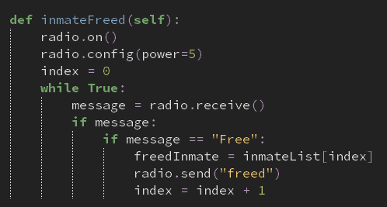
When an attacker attempts to free their teammate from jail, the jail will point to the person that was in jail for the longest, by using the inmateList and seeing who is first in the queue. This is different to the original CTF game because attackers can decide who they want to free. This may seem as a disadvantage as attackers may want to choose the better player rather than being a likelihood that they might be chosen, depending on whether they are first in queue. However, this could be countered as attackers would now have to be strategic about their game plan; if there is a player, say A, that is stuck in jail, and then player B is stuck in jail. If player B is the relatively better player than A, then they will have to wait to be freed until player A gets freed from jail, so that player B is the next inmate that will be freed.
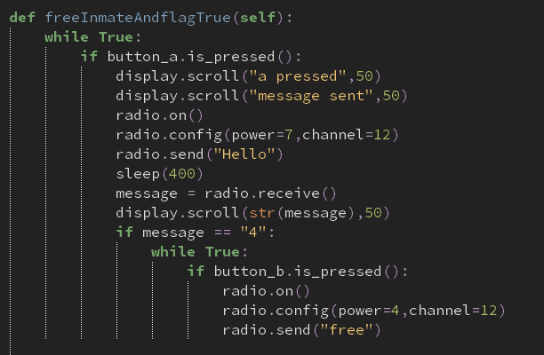
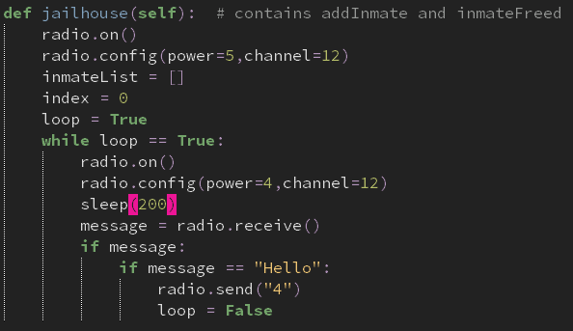
What I will be testing before any of this works is If there is a communication established between the attacker attempting to free their ally from jail and the jailhouse. The attacker will see if the jailhouse is near them. If it is, then the attacker will press a to take the inmate first held in the queue data structure. The screenshots below show the radio communications between the jail and attacker respectively. For testing purposes, only when button a is pressed on the attacker bit is when the program will execute

What’s being tested | Input | Just | Out | What next
Attacker and Jail communication | Jail | Sends back “4” when the attacker is close to the jailhouse so the player will know when to press A as it will be displayed on their microMap | See video, works | NA

Back to the main method I’m testing, the way that this will be done is by first having to put a player in jail, and this message will be sent from the jail to the attacker that’s being sent to jail. The first screenshot below shows this. After this, I would have to free them from jail with the help of another player. The second screenshot shows this. The list will be tested later on, as for now, all I am testing is if an inmate is successfully freed when the attacker presses A at a close distance.
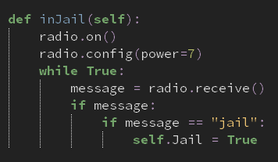
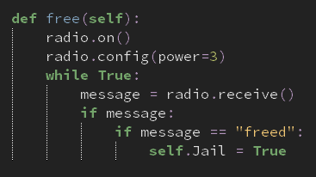

What is being tested | Input | Just | Output | What next
Is player freed from jail | Attacker rescuing player | To free the player from jail | “None” displayed on attack microbit assuming that there was no message sent to the jail. | Make it so that when a player is sent to jail, they’re sent to jail for the rest of the game and cannot be freed.

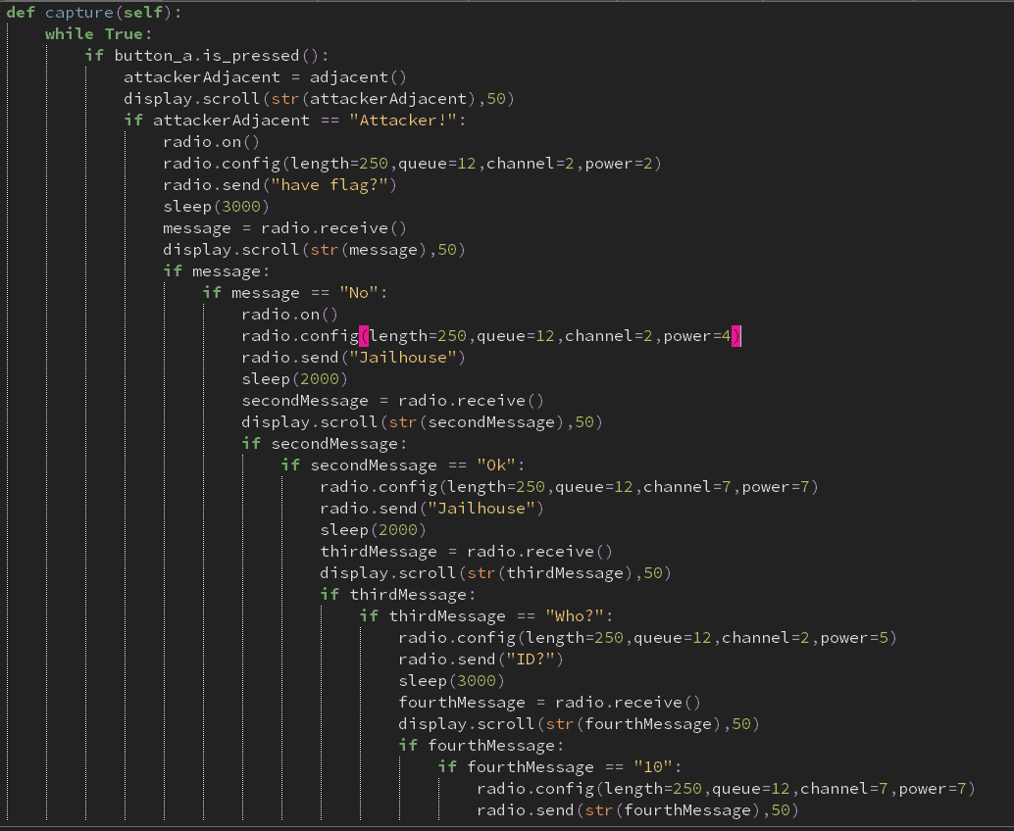

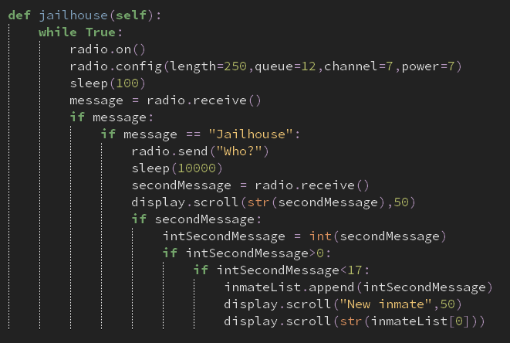

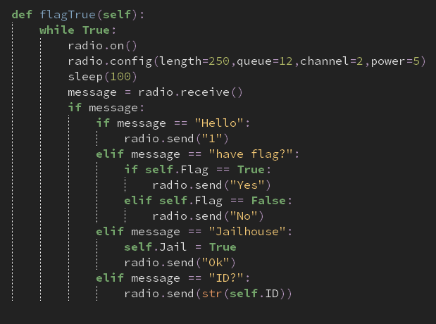

What am I testing | Input | Just | Out | Next steps
The communication between my jail, defender and attacker/inmate | Button A  Attacker ID  “Questions” sent from the jailhouse to the defender and/or from the defender to the attacker  “Answers” sent from the attacker indirectly to the jailhouse using the defender as a messenger | To successfully send the attacker to the jailhouse | Line 71, my radio send uses two arguments when only one is supposed to be used. This is in my defender class | Remove the second argument, 50, from the radio.send function  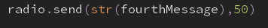  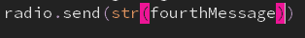
 |  |  | Line 47 in my jailhouse class, inmateList isn’t defined | Would have to be defined within my __init__ method as it is required outside and inside my jailhouse method  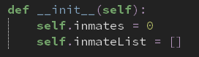
 |  |  | Line 49 has a name error | I have mistakenly tried to scroll inmateList instead of self.inmateList
 |  |  | See video, works | NA

I have developed my code so that the number of inmates is incremented by one every time the defenders successfully catch an attacker. I have further developed my code my scrolling the ID of the new inmate that has arrived, rather than just for testing purposes of just scrolling the first attacker.
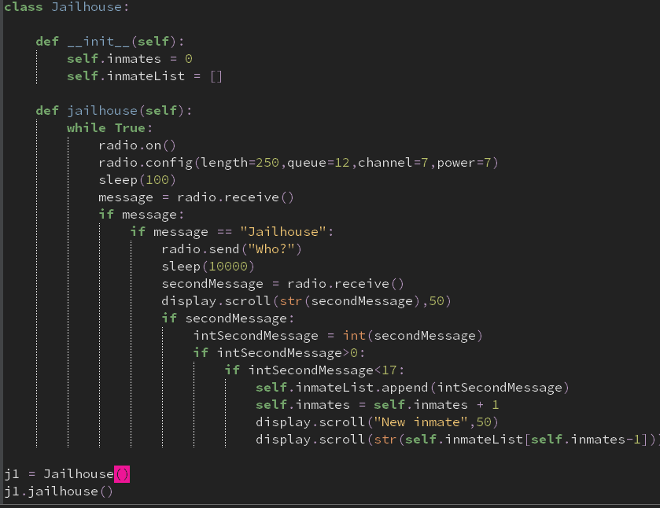
The flagTrue method in my attacker class is now fully working.
I tried to establish a method that allows my attacker to free other attackers from jail. However, there was no correct output after several hours of trying. So to make life easier for me, I have decided to tweak the criteria of my project so that instead of attackers being freed from jail, they have to stay in jail for the rest of the game. This is a massive alter for my game as freeing inmates is such a great way for them to have a second chance with a price to pay. However, it could be argued that this can improve the strategic play required in the game.
I tried implementing my own array of radio communications so that I can plot all the possible combinations for radio channels between two microbits that can work by using the x or y coordinate plane first. However, the program hadn’t even executed so far so that it could even be used.
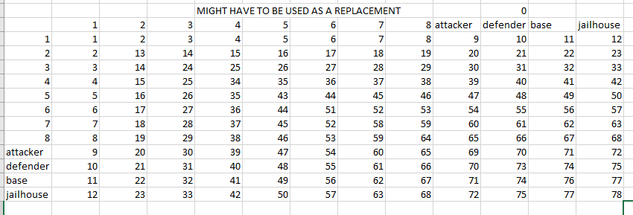

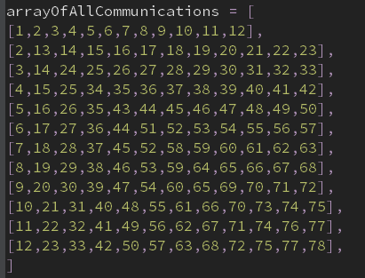

I also tried to alter my code for the sake of the jailhouse having to switch between two channels between one while loop. However, although my python syntax had been going accordingly, the logical syntax had blocked me from enabling this to happen, and essentially having to stop the idea of freeing inmates from jail.
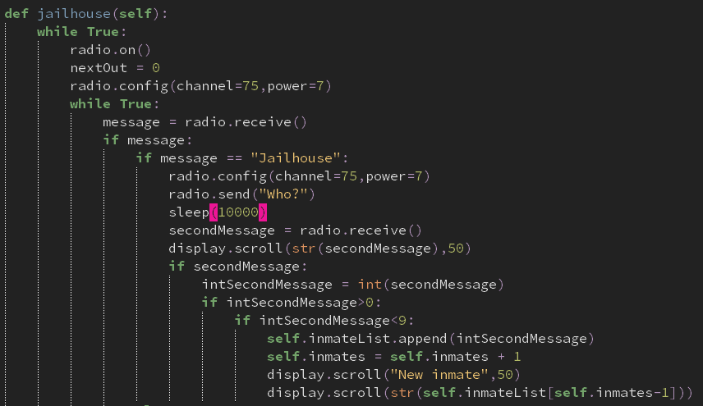

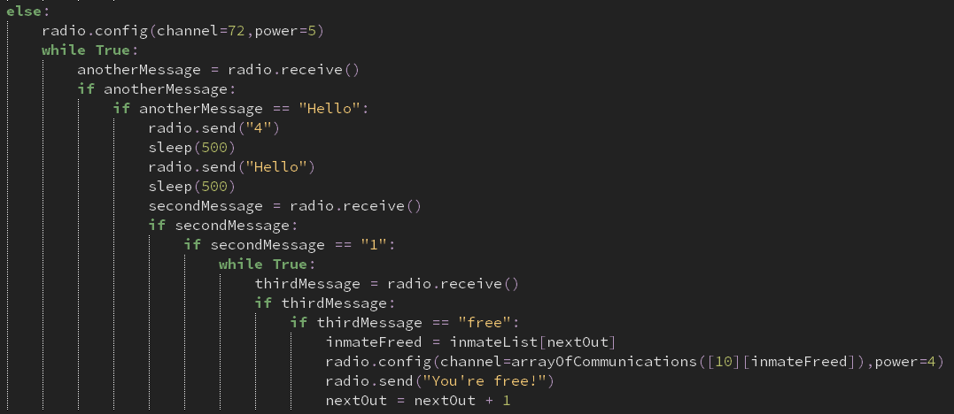
I didn’t have enough time to finish off my stop my

